
COMSATS UNIVERSITY ISLAMABAD , ATTOCK CAMPUS
SUBMITTED BY :
ZEESHAN AHMED
SP22-BSE-019
SUBMITTED TO:
SIR KAMRAN

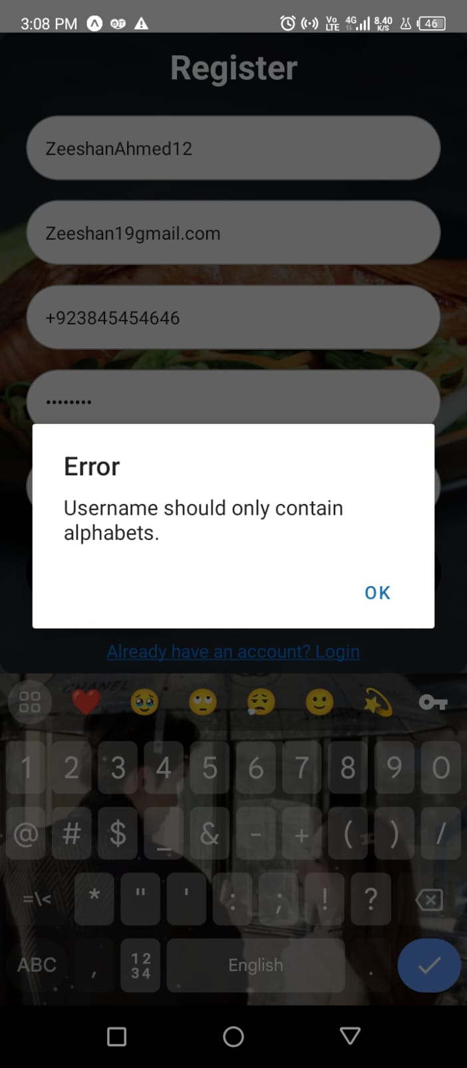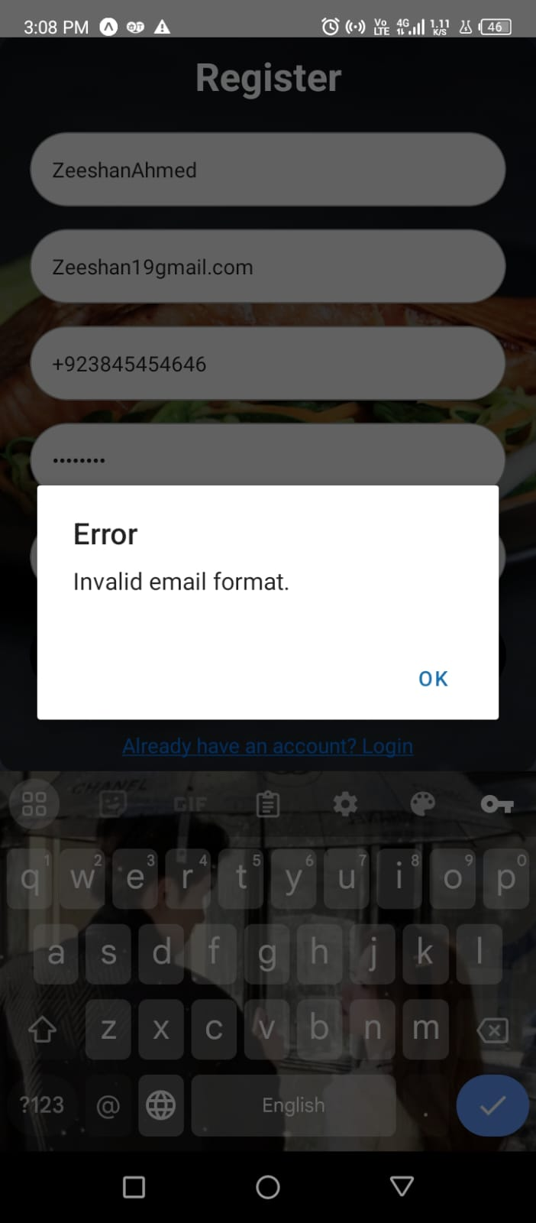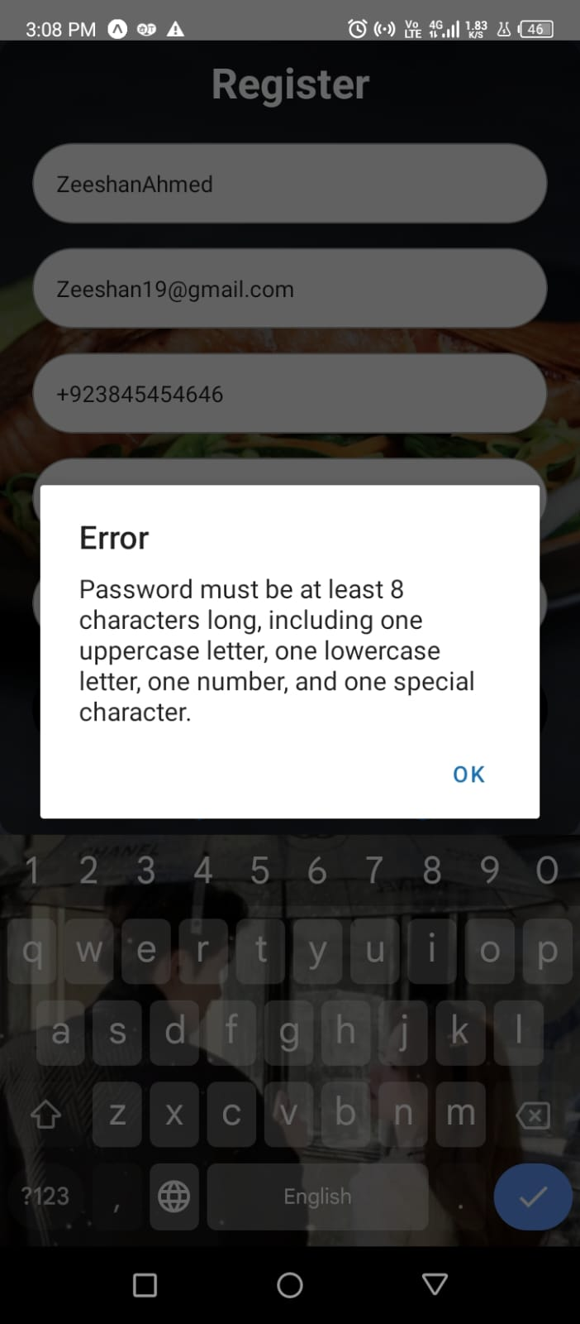
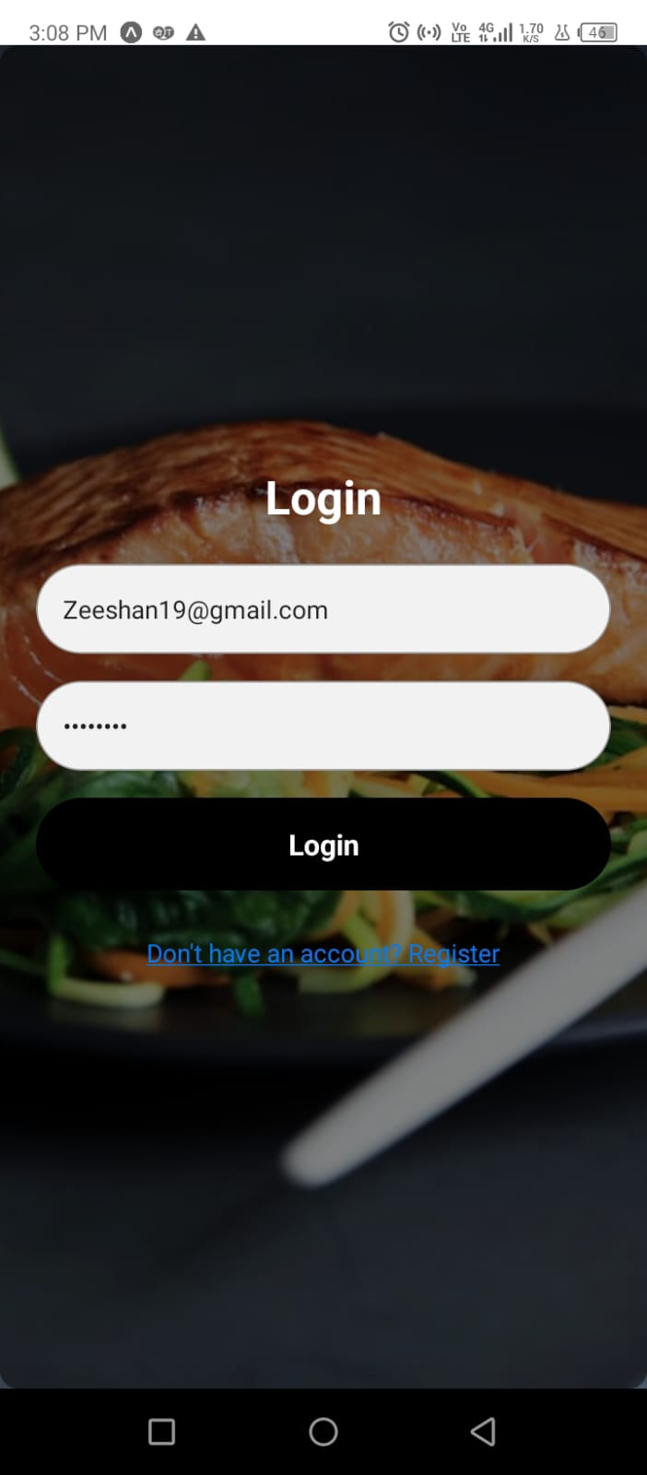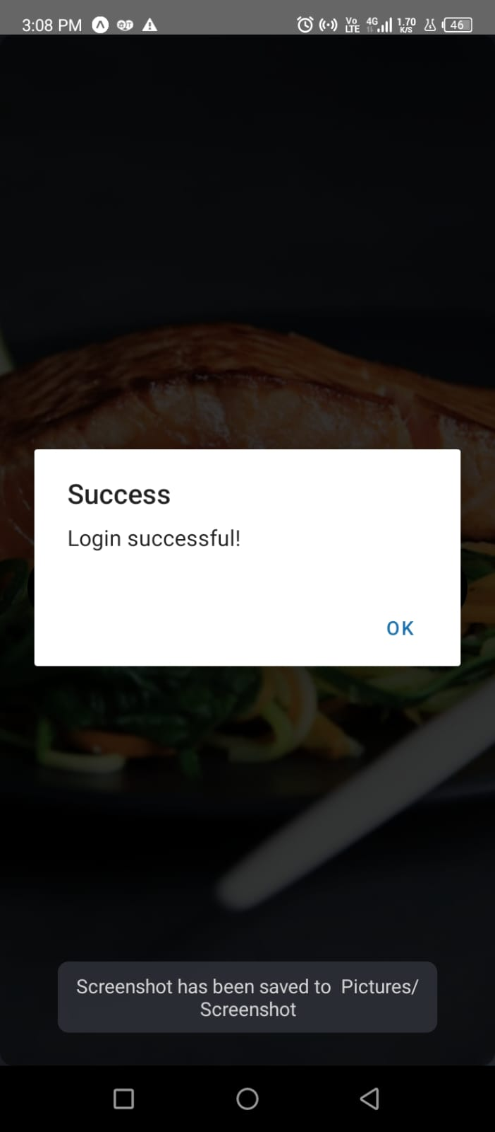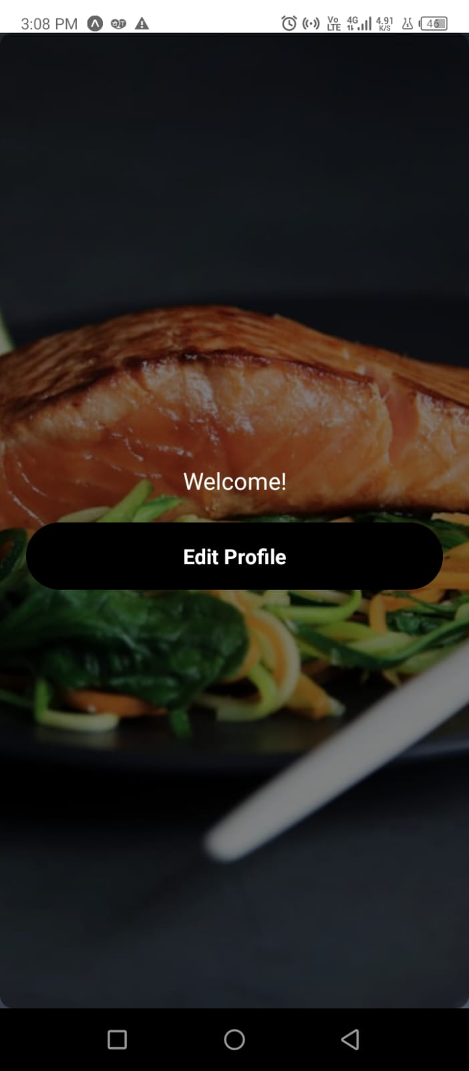
CODE:
import React, { useState } from 'react';
import { SafeAreaView, StyleSheet, View, TextInput, Text, TouchableOpacity, Alert, ImageBackground } from 'react-native';
import * as SecureStore from 'expo-secure-store';

const App = () => {
const [currentScreen, setCurrentScreen] = useState('login');
const [username, setUsername] = useState('');
const [email, setEmail] = useState('');
const [password, setPassword] = useState('');
const [confirmPassword, setConfirmPassword] = useState('');
const [phone, setPhone] = useState('');

// Registration validation
const handleRegistration = async () => {
const usernamePattern = /^[A-Za-z]+$/;
if (!usernamePattern.test(username)) {
Alert.alert('Error', 'Username should only contain alphabets.');
return;
}

const emailPattern = /^[^\s@]+@[^\s@]+\.[^\s@]+$/;
if (!emailPattern.test(email)) {
Alert.alert('Error', 'Invalid email format.');
return;
}

const passwordPattern = /^(?=.*[a-z])(?=.*[A-Z])(?=.*\d)(?=.*[@$!%*?&])[A-Za-z\d@$!%*?&]{8,}$/;
if (!passwordPattern.test(password)) {
Alert.alert(
'Error',
'Password must be at least 8 characters long, including one uppercase letter, one lowercase letter, one number, and one special character.'
);
return;
}

if (password !== confirmPassword) {
Alert.alert('Error', 'Passwords do not match.');
return;
}

try {
const userData = { username, email, password, phone };
await SecureStore.setItemAsync('user', JSON.stringify(userData));
Alert.alert('Success', 'Registration successful!');
setCurrentScreen('login');
} catch (error) {
Alert.alert('Error', 'Failed to save data.');
}
};

const handlePhoneChange = (input) => {
const fixedPrefix = "+923";
const remainingDigits = input.replace(fixedPrefix, "");
const sanitizedInput = remainingDigits.replace(/\D/g, "");
const fullPhoneNumber = fixedPrefix + sanitizedInput;

if (fullPhoneNumber.length <= 13) {
setPhone(fullPhoneNumber);
}
};

const handleLogin = async () => {
try {
const storedData = await SecureStore.getItemAsync('user');
const user = storedData ? JSON.parse(storedData) : null;

if (user && user.email === email && user.password === password) {
Alert.alert('Success', 'Login successful!');
setCurrentScreen('welcome');
} else {
Alert.alert('Error', 'Incorrect email or password.');
}
} catch (error) {
Alert.alert('Error', 'Failed to fetch data.');
}
};

return (
<SafeAreaView style={styles.container}>
<ImageBackground
source={{ uri: 'https://images.unsplash.com/photo-1519708227418-c8fd9a32b7a2?crop=entropy&cs=tinysrgb&fit=max&fm=jpg&q=80&w=1080' }}
style={styles.backgroundImage}
>
<View style={styles.innerContainer}>
{currentScreen === 'register' && (
<>
<Text style={styles.titleText}>Register</Text>
<TextInput
placeholder="Username"
value={username}
onChangeText={setUsername}
style={styles.input}
/>
<TextInput
placeholder="Email"
value={email}
onChangeText={setEmail}
keyboardType="email-address"
style={styles.input}
/>
<TextInput
placeholder="Phone Number"
value={phone}
onChangeText={handlePhoneChange}
keyboardType="phone-pad"
style={styles.input}
/>
<TextInput
placeholder="Password"
value={password}
onChangeText={setPassword}
secureTextEntry
style={styles.input}
/>
<TextInput
placeholder="Confirm Password"
value={confirmPassword}
onChangeText={setConfirmPassword}
secureTextEntry
style={styles.input}
/>
<TouchableOpacity onPress={handleRegistration} style={styles.button}>
<Text style={styles.buttonText}>Register</Text>
</TouchableOpacity>
<TouchableOpacity onPress={() => setCurrentScreen('login')} style={styles.switchButton}>
<Text style={styles.switchButtonText}>Already have an account? Login</Text>
</TouchableOpacity>
</>
)}

{currentScreen === 'login' && (
<>
<Text style={styles.titleText}>Login</Text>
<TextInput
placeholder="Email"
value={email}
onChangeText={setEmail}
keyboardType="email-address"
style={styles.input}
/>
<TextInput
placeholder="Password"
value={password}
onChangeText={setPassword}
secureTextEntry
style={styles.input}
/>
<TouchableOpacity onPress={handleLogin} style={styles.button}>
<Text style={styles.buttonText}>Login</Text>
</TouchableOpacity>
<TouchableOpacity onPress={() => setCurrentScreen('register')} style={styles.switchButton}>
<Text style={styles.switchButtonText}>Don't have an account? Register</Text>
</TouchableOpacity>
</>
)}

{currentScreen === 'welcome' && (
<View style={styles.container}>
<Text style={styles.text1}>Welcome!</Text>
<TouchableOpacity
style={styles.button}
onPress={() => Alert.alert('Profile Action', 'This could navigate elsewhere')}
>
<Text style={styles.buttonText}>Edit Profile</Text>
</TouchableOpacity>
</View>
)}
</View>
</ImageBackground>
</SafeAreaView>
);
};

const styles = StyleSheet.create({
container: {
flex: 1,
justifyContent: 'center',
paddingTop: 25,
},
backgroundImage: {
flex: 1,
justifyContent: 'center',
},
innerContainer: {
flex: 1,
justifyContent: 'center',
borderRadius: 10,
padding: 20,
backgroundColor: 'rgba(0, 0, 0, 0.5)', // Adjust opacity for contrast
},
titleText: {
fontSize: 26,
fontWeight: 'bold',
textAlign: 'center',
marginBottom: 20,
color: '#fff',
},
input: {
height: 50,
borderColor: '#999',
borderWidth: 1,
marginBottom: 15,
paddingHorizontal: 15,
borderRadius: 50,
backgroundColor: '#f2f2f2',
},
button: {
backgroundColor: 'black',
padding: 15,
borderRadius: 50,
marginBottom: 15,
alignItems: 'center',
},
buttonText: {
color: 'white',
fontWeight: 'bold',
fontSize: 16,
},
switchButton: {
alignItems: 'center',
marginTop: 10,
},
switchButtonText: {
color: '#007bff',
textDecorationLine: 'underline',
fontSize: 14,
},
text1: {
fontSize: 18,
marginBottom: 20,
color: 'white',
textAlign: 'center',
},
});

export default App;

